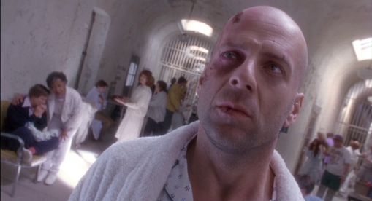
The Dutch angle is a type of camera shot where the camera is set at an angle on its roll axis so that the shot is composed with vertical lines at an angle to the side of the frame, or so that the horizon line of the shot is not parallel with the bottom of the camera frame. This produces a viewpoint akin to tilting one's head to the side.

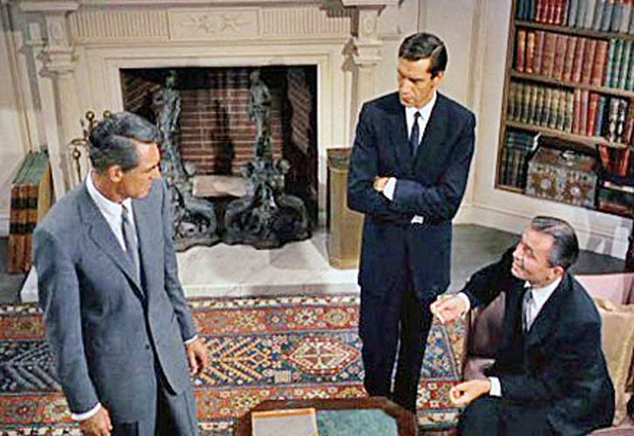

A high-angle shot is where the camera looks down on the subject from a high angle and the point of focus often gets "swallowed up." High-angle shotscan make the subject seem vulnerable or powerless when applied with the correct mood, setting, and effects.

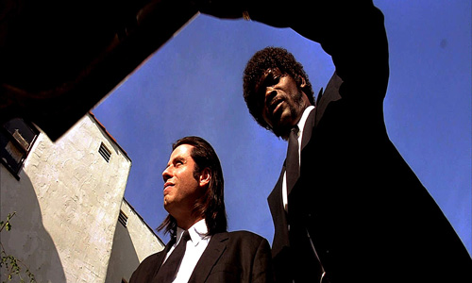
low-angle shot, is a shot from a camera angle positioned low on the vertical axis, anywhere below the eye line, looking up. Sometimes, it is even directly below the subject's feet. Psychologically, the effect of the low-angle shot is that it makes the subject look strong and powerful.

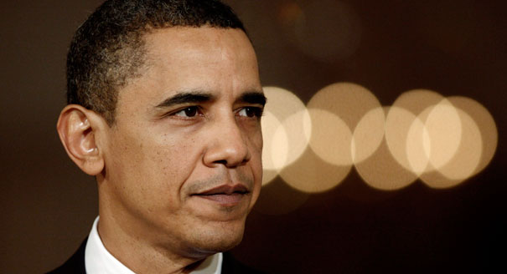
A close-up is a type of shot, which tightly frames a person or an object.

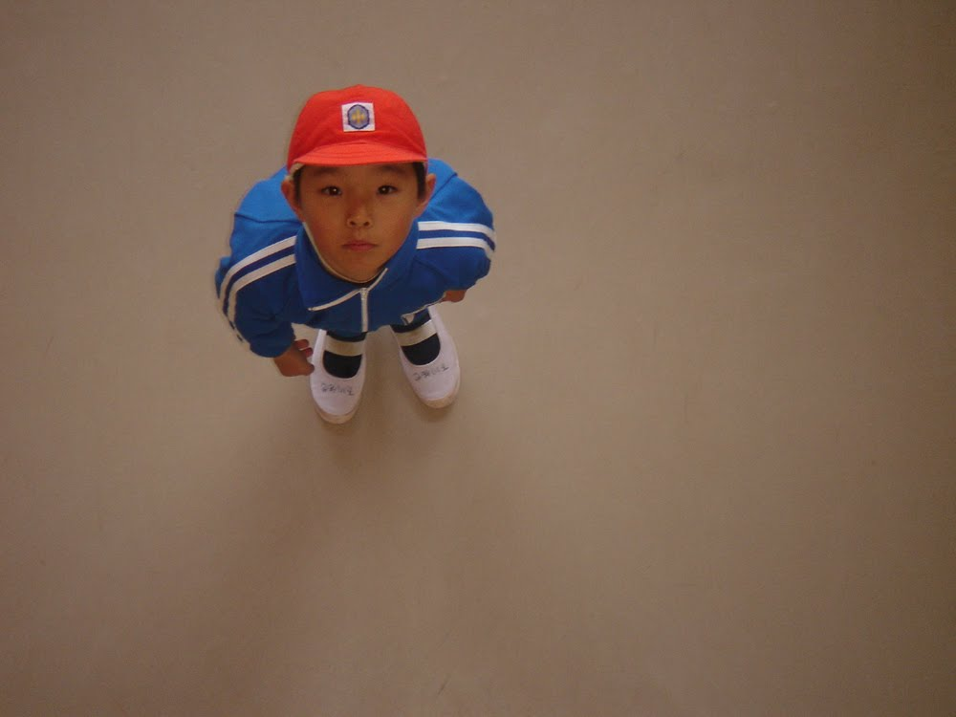

The overhead shot camera angle is one of the most interesting and specialized of all the camera angles...! It is also called the "Bird's-Eye" view, "Raised" or "Elevated" shot. It's not just a high angle shot… In this angle the scene is shown from almost directly (or directly) above the subject.

